Assignment 5 report
A report on assignment 5
Thomas Juranich

Table
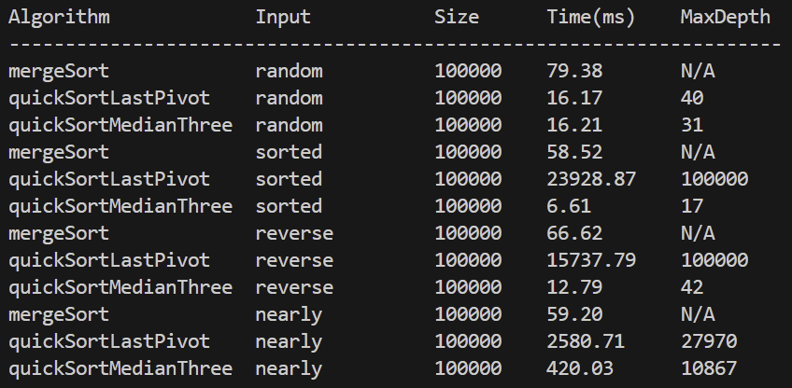

Part 1
- How does median-of-three pivot selection improve QuickSort?
  - By doing a pre-check to find the optimal median, it eliminates the worst case.
  - More consistency for getting a good patrician, to sort the list faster without having to go deeper.
- Compare the recursion depth of the two QuickSort versions.
  - For last quick sort, with sorted arrays, you end up with O(n) recursion depth, since each call is only removing one element in the range, it will take a long time and be very inefficient, basically forcing the depth of sorted lists to go as deep as the elements inside it.
  - Median splits the array more evenly, so even if you don’t end up with a perfect split, you get a much more even O(log n) recursion depth on average since it can deal with sorted lists more easily by picking the best pivot.
- Why does MergeSort not suffer from the same degeneration?
  - Because regardless of the list’s size or the way it is sorted, it MergeSort sorts the same way regardless of the size.
  - The degradation on quicksort happens when things are sorted leaving to a bad pivot being chosen, while MergeSort divides the array the same regardless of the elements in the array, then it basically zips all of the separated subarrays like a big zipper after.

Part 2
- Why is QuickSelect faster than sorting the entire array when finding the kth smallest element? What’s the time complexity?
  - Because Quick Select only sorts the side of the array that the element is on, and ignores the other side of the array and only continues what it needs to.
  - Time complexity is basically a geometric series, where the sum of a geometric series is 2n, so the average case is closer to O(n), same for best case being O(n).
  - Worst case is still O(n^2) due to the worst case of a sorted list still giving a horrible patrician.

